CPSC 4317: Computer Networks
Homework 1
Due 10:00 am, Sept. 6, 2024 (Friday)

Name: ____Andrew Kalathra______

LUID: _____L20498001_______

Date: _______09/06/2024_______

The following questions are 10 points each:

Textbook: P. 15 ->

- Question 1.11: List the layers in the TCP/IP Model, and give a brief explanation of each.
  - Physical: the lowest layer (layer 1), contains how the data is actually transmitted, such as through medium and hardware, along with specifics on radio waves, signals, and the likes.
  - Network Interface: the second layer (layer 2), also known as the “Data Link” layer as it specifies how the data is communicated from the higher layers to the physical layer. It addresses things such as network addresses, maximum packet size for a network, protocols for mediums, and addressing.
  - Internet: the middle layer (layer 3) that is the fundamental point of the internet. Protocols are most important here as they span across multiple interconnected networks.
  - Transport: the second highest layer (layer 4) serves as a communication between the computer application and how data is sent. Specifics seen here are the max receiver rate of data, control of congestion of network traffic, and receiving packages in the right order.
  - Application: the highest layer (layer 5) is how the user interacts with the data. The format, meaning, procedure, and all high level steps are interpreted here with all the intermediate steps being hidden from the user.

Textbook: P. 80 ->

- Question 4.9: What data objects does a browser cache, and why is caching used?
  - Browser’s cache documents sent from web servers. This includes web pages, downloaded documents, and images (JPEG, GIF, …).
  - Browser’s do not cache small items.
  - Browser’s cache items by saving a copy to the user’s disk in an attempt to optimize web access. In this way, repeated visits and downloads from web sites can be easily and quickly recalled without putting much strain on the network.

- Question 4.12: When a user requests an FTP directory listing, how many TCP connections are formed? Explain.
  - A File Transport Protocol (FTP) server allows the transport of files from the server to the client.
  - The client first initiates a control connection, which the server replies to by accepting.
  - The client then sends the directory request through this connection.
  - The server then forms a data connection and then transfers the directory listing. Following this, the server closes the data connection.
  - In short, two connections are made, one for the control on what the client wants, and another for the data to be transferred through.

- Question 4.16: List the three types of protocols used with email, and describe each.
  - Transfer: this protocol is meant to move a copy of an email from one computer to another, like sending a copy from one person to another
  - Access: this protocol allows the user to access their mailbox, view their emails, and send emails
  - Representation: this protocol specifies the format of the email when stored on the disk

- Question 4.22: What is the overall purpose of the Domain Name System?
  - The DNS maps the IP address to a symbolic name.
  - In Cybersecurity systems, we commonly said the DNS is used to map the IP address to the MAC address in local area networks (LANs).
  - This is an application of such. On a wide scale, a DNS helps us map the name of a website we may know to the specific IP address that is used to get the source code from the specific server it is saved on.
  - There is a hierarchy in this system in that there is a top level domain (TLD), with every level below it being another DNS. Each links to each other, building a tree-like structure. In this way, multiple servers can partake in finding the IP address using their own DNS.

Programming Question (50 points):

Please read chapter 3 to have a basic understanding about socket programming.

After this, please download “example socket program” (socket_program.tar.gz) in the BlackBoard website. Please upload socket_program.tar.gz to a linux machine, then run:
- gunzip socket_program.tar.gz
- tar xvf socket_program.tar
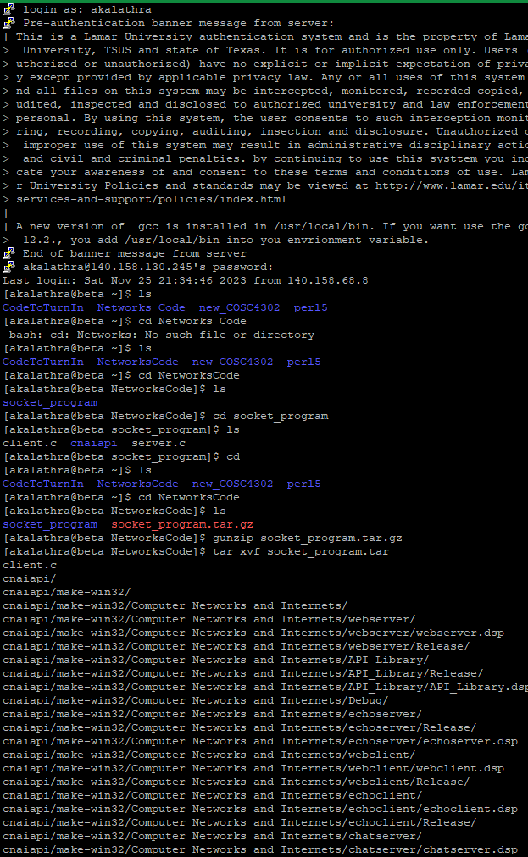
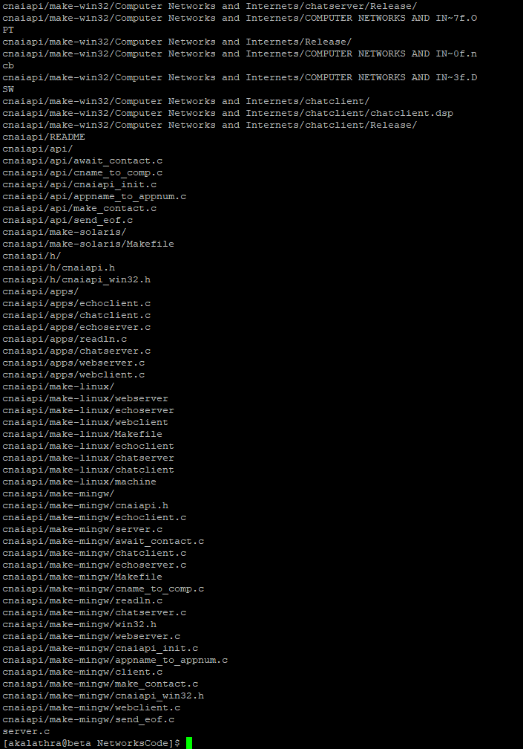

you will obtain the list of socket programs. Please refer to video “Socket Demo” to see how to use these socket programs.

In these socket programs, there are client.c and server.c. Please compile and run these two programs and make them work. Please

- Explain the basic functionality of server.c and client.c
  - In server.c
    - The main method contains a few variables. The main ones include a variable to hold the server socket address, denoted as sad, and a variable to hold the client socket address, denoted as cad. Another important variable is the port variable, which holds the port number. Finally, the last important variable is the visits variable, which is a counter that stores the amount of visits received.
    - All other variables are there but not important to this discussion.
    - The first if-else statement checks if a port was specified. If it was, then the port variable is set to the input, otherwise the port is automatically set to the default port.
    - The second if-else statement just checks for illegal ports.
    - The third if-else statement is irrelevant. (use TCP protocol)
    - Two variable are then defined, sd and sd2, as a socket functions. These functions have 3 parameters and are used to make a socket. The following if statement is used to check it for errors, with the next if statement used to bind a local address to the socket.
    - Following this, the server listens for a connection.
    - When the server gets a request, the while loop will start.
      - A new socket will be created, sd2, to transfer a line. The if statement will show an error if the socket cannot be made, or
      - The number of visits will increment by 1. Then the line “This server has been contacted # times” will be printed with the # representing the variable visits.
    - The socket will then close at the end of this while loop. This is an infinite loop, so it will continue to listen until the server stops running.
  - In client.c
    - The main method contains a few similar variables. There is a variable to hold the IP address of the server, denoted as sad. Alongside this, there is still the port number that has the same function, to connect to the right port.
    - The same two if-else statements are used to connect to the specified port, or if none is given, then to the default port.
    - Additionally, an if-else statement is given to check the host. If none is given, then the default host will be assigned. (This is the server host). A few more if-else statements are meant to run through connecting/mapping the host and protocol number.
    - A socket is then created, sd, with its own if statement checker and connection checker.
    - The client then receives from sd, stores the buffer in a variable n, prints the buffer, prints the length of n, and then clears n (and prints that length as well).
    - Following this, the client closes the socket using the closesocket api.

- Run server and client.
  - 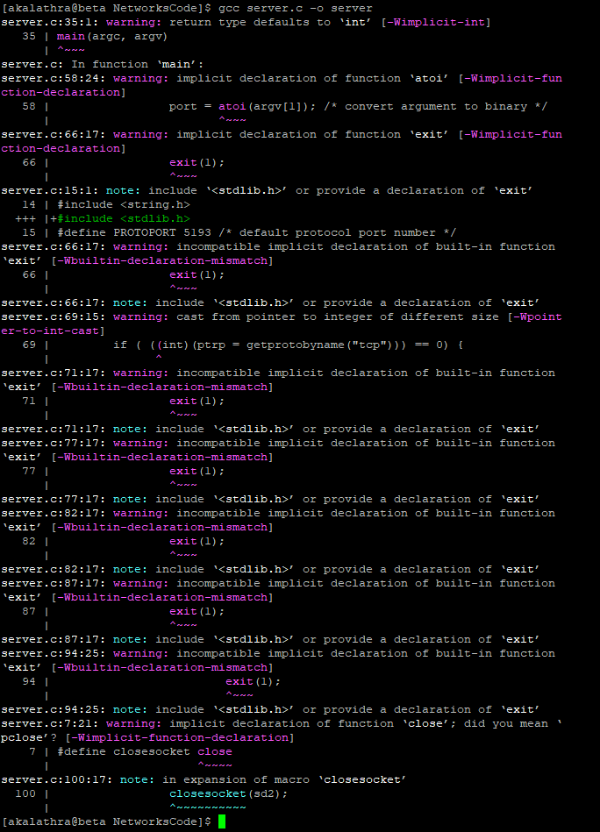
  - 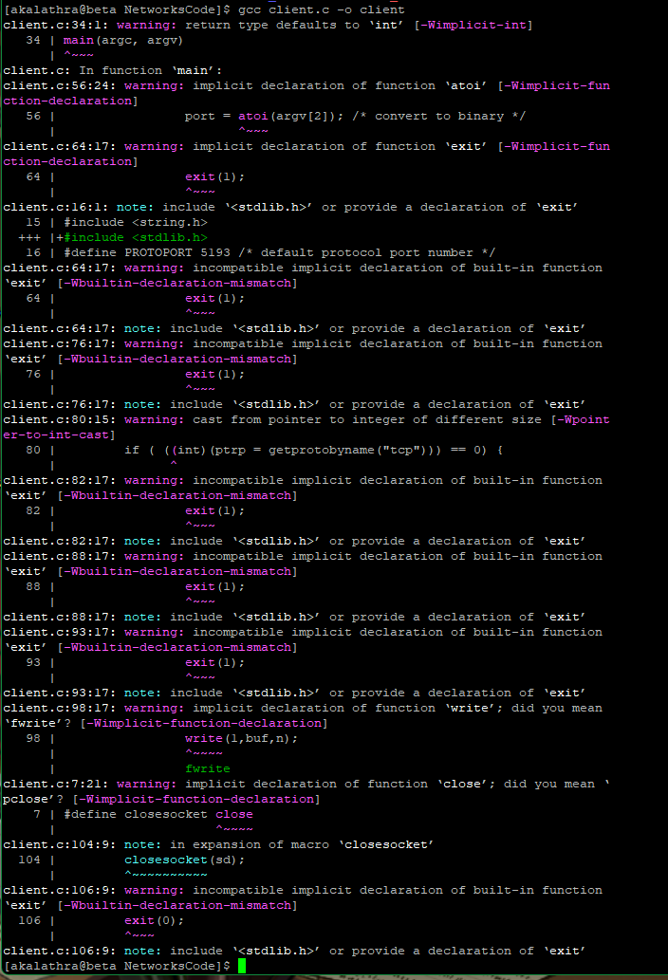

- Turn in a screenshot to show how you run them.
  - 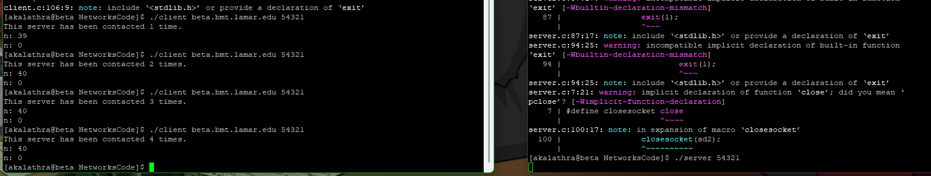

How to Turn In:

Only softcopy is required.
- Please use the blackboard system to turn in the softcopy of all your solutions.
- For programming questions, please do NOT use MS WORD. Please send .c files.

